Xv6 OS

xv6 is a nifty operating system that is essentially a re-implementation of Sixth Edition Unix that, unlike most of the huge monolithic Linux or BSD distributions that you'd run on your workstation or server, is simple enough to be used as a learning tool. Though xv6 lacks in functionality that you'd expect from a modern operating system, much of the core UNIX concepts and structure remain the same. xv6 is also very lightweight, only taking a few seconds to compile and allows remote debugging. This all makes it great for understanding how modern operating systems hang together.

In fact, xv6 was developed by MIT as a teaching operating system for their 6.828 course. The course page for 6.828 is a great resource that MIT are kind enough to have publicly available.

MIT also produce a fantastic xv6 reference book that provides commentary on the structure of the xv6 operating system. Additionally, the xv6 source actually self documents - the xv6 make file contains a target (make xv6.pdf) that generates a pdf of the source code, which amazingly comes in under 100 pages and 10k lines of source (including comments!). Not bad for an entire, functional, operating system.

xv6 is typically run virtualized using qemu on a Linux host machine. To get started with xv6, clone the xv6 repo:
git clone git://github.com/mit-pdos/xv6-public.git xv6

Then to start it as a virtual machine under qemu:

cd xv6
make qemu

If make fails, make sure you have your compiler toolchain installed. There's some good info on the 6.282 tools page. For me, on Fedora, I needed to install gcc with dnf install gcc.

Once you have your compiler toolchain working, qemu will pop up and you'll be presented with the xv6 shell.
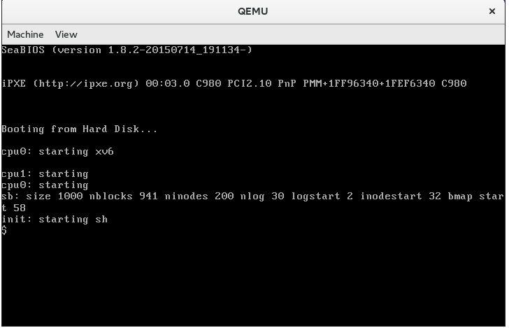

Qemu

QEMU is a generic and open source machine emulator and virtualizer.
When used as a machine emulator, QEMU can run OSes and programs made for one machine (e.g. an ARM board) on a different machine (e.g. your own PC). By using dynamic translation, it achieves very good performance.
When used as a virtualizer, QEMU achieves near native performance by executing the guest code directly on the host CPU. QEMU supports virtualization when executing under the Xen hypervisor or using the KVM kernel module in Linux. When using KVM, QEMU can virtualize x86, server and embedded PowerPC, 64-bit POWER, S390, 32-bit and 64-bit ARM, and MIPS guests.
QEMU is a member of Software Freedom Conservancy.
QEMU releases can be downloaded here: https://www.qemu.org/download/

